Hiyab Mengisteab
Task 2: Cloud Data Solution Implementation

Part A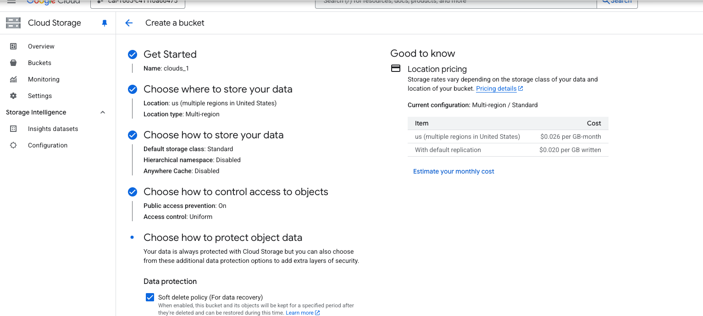
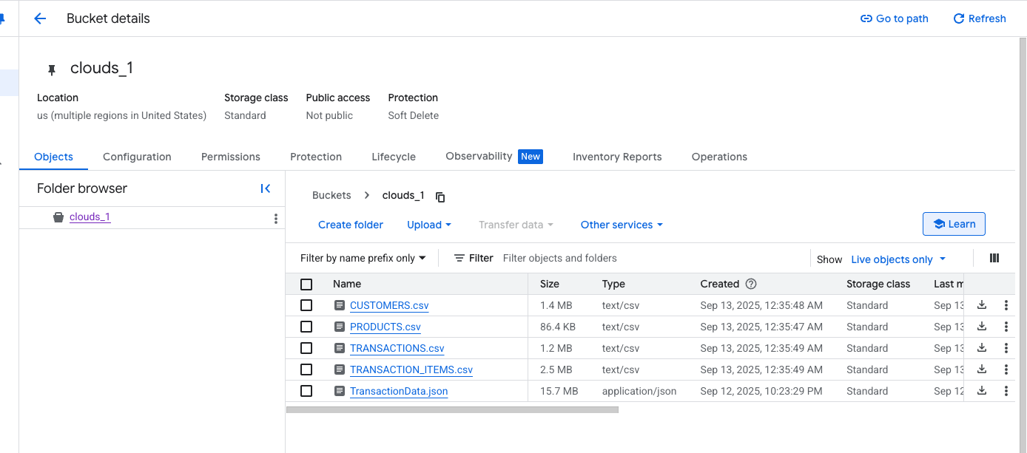
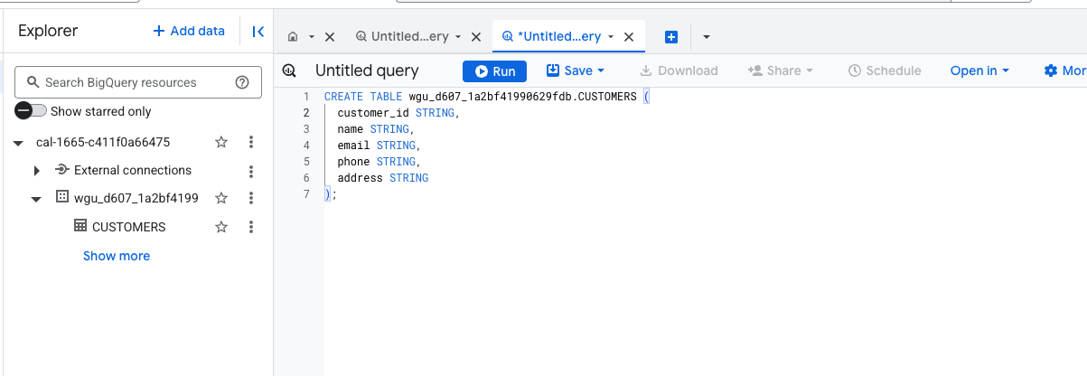
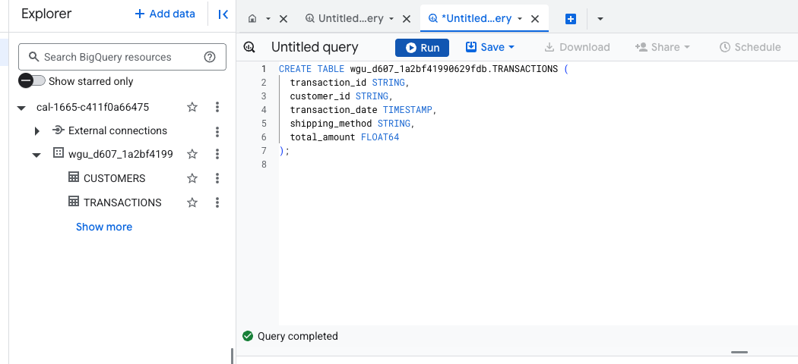
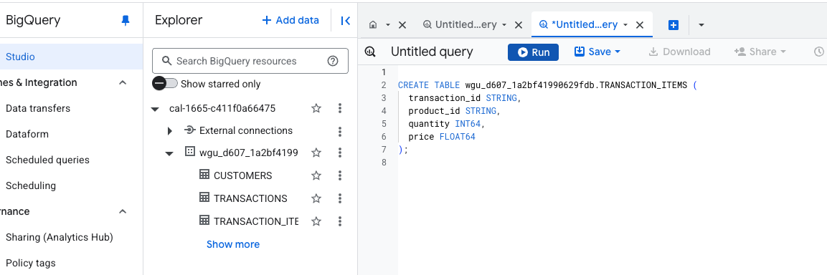
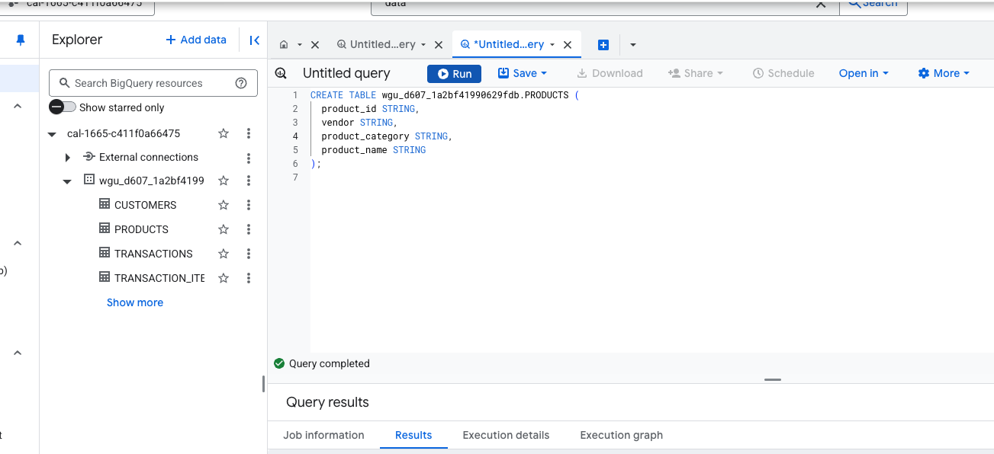
- I used the CREATE TABLE statement in SQL to create new tables in the database. While creating each table, I defined the columns and assigned appropriate data types to them. For instance, I used STRING for text data like names or emails, FLOAT64 for decimal numbers such as prices or totals, INT64 for whole numbers like IDs or quantities, and TIMESTAMP for date and time values like transaction dates.

 | Part B
1 | 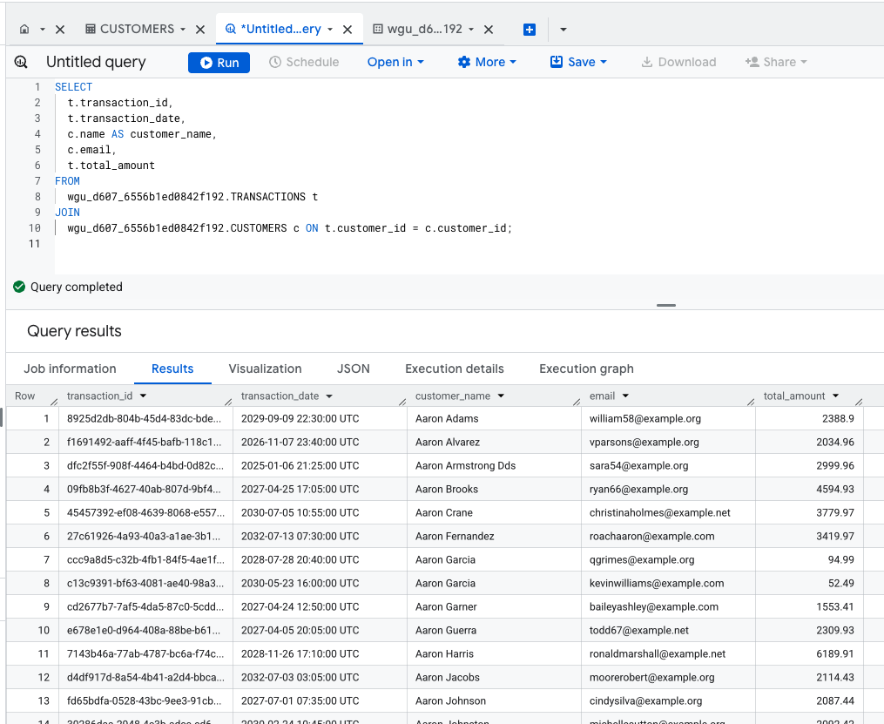
2 | This SQL query retrieves a list of transactions along with customer details. It gets the transaction ID, date, total amount, and the customer's name and email. The data comes from two tables: TRANSACTIONS and CUSTOMERS. These tables are joined using the customer_id, which links each transaction to the customer who made it. This way, the query shows which customer made each transaction and includes their contact info.

 | Part C
1 | 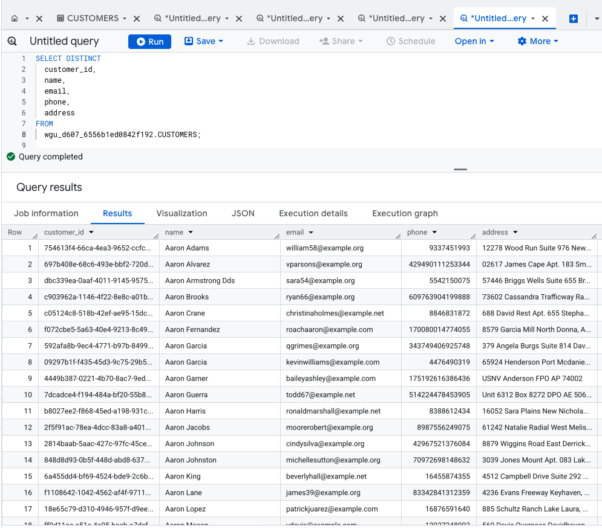
2 | 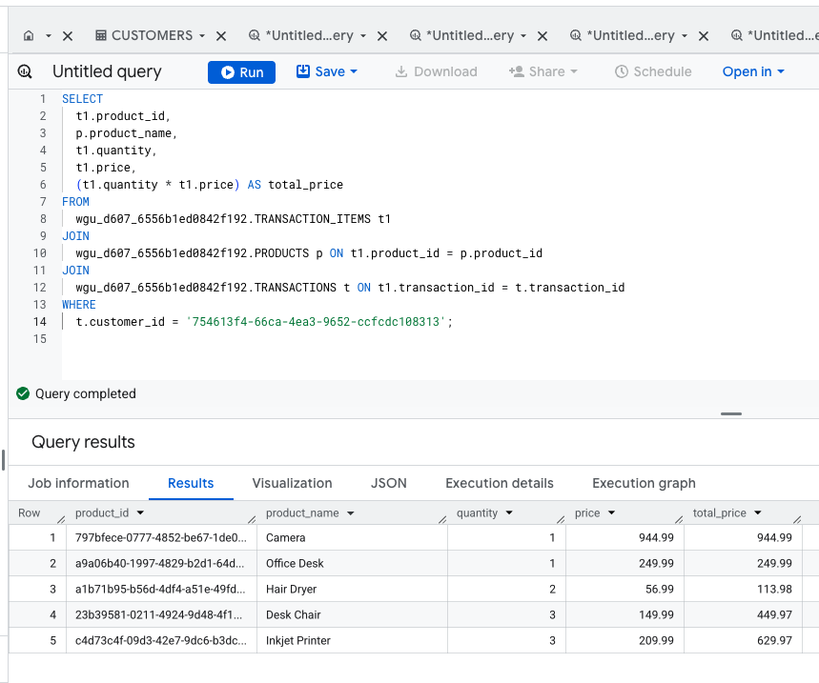
3 | 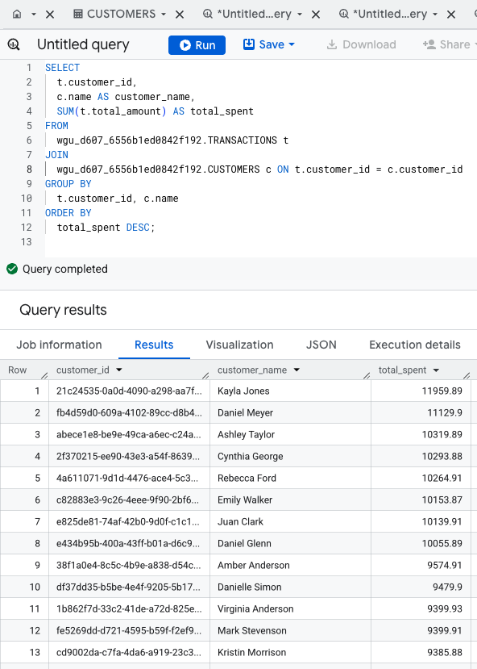

Reference:
- External resources not used in this submission

